**PRAKTIK**

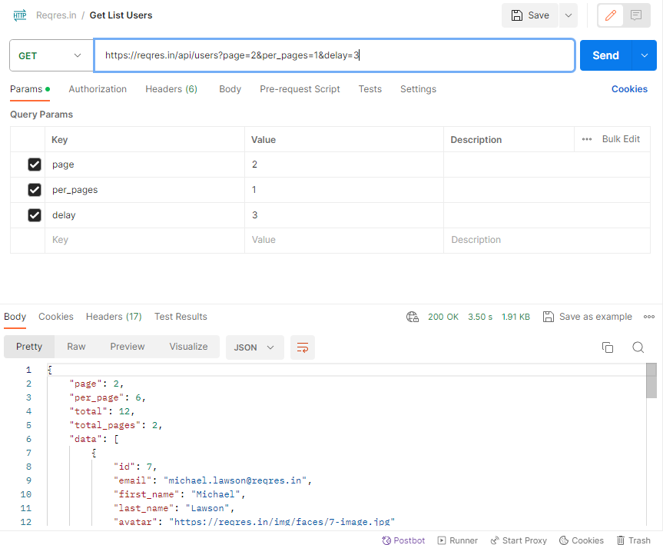

| **Input**  describe('Get User List', () => {  it('Verity the list users will displayed',() => {  cy.request({  method: 'GET',  url: 'https://reqres.in/api/users?page=2&per_pages=1&delay=3'  }).as('users')  cy.get('@users').its('status').should('equal', 200)  });  }); |
| --- |
| **Output** |

**TUGAS**

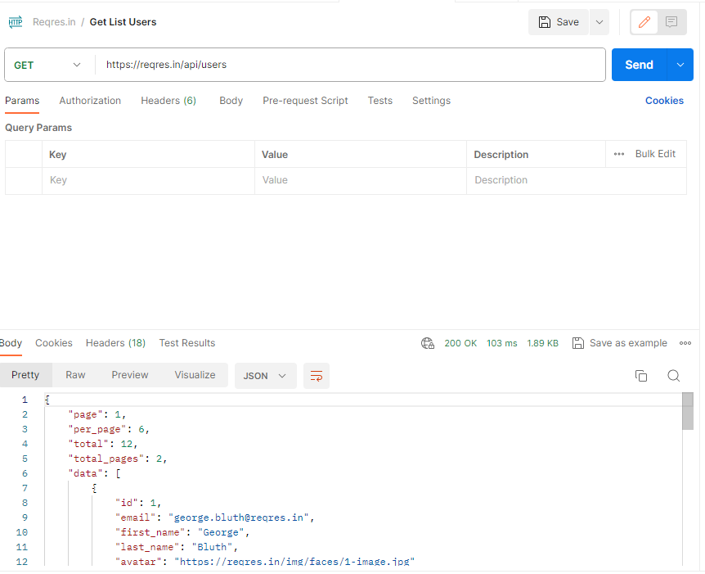

| **Input**  describe('Get User List', () => {  it('Verity the list users will displayed',() => {  cy.request({  method: 'GET',  url: 'https://reqres.in/api/users'  }).as('users')  cy.get('@users').its('status').should('equal', 200)  });  }); |
| --- |
| **Output** |